**Creating an EC2 Auto Scaling Group  
Using a Launch Template**

**Step 1 – Create the Launch Template**

1. Open the Amazon EC2 console at <https://console.aws.amazon.com/ec2/> and choose the N. Virginia region.
2. On the navigation pane, under **INSTANCES**, choose **Launch Templates**.
3. Choose **Create launch template**. Enter the name ***yourlastname-launch-tmp*** and provide a description of ***Launch template for ASG*** for the initial version of the launch template.
4. Under **Auto Scaling guidance**, select the check box to have Amazon EC2 provide guidance to help create a template to use with Amazon EC2 Auto Scaling.  
   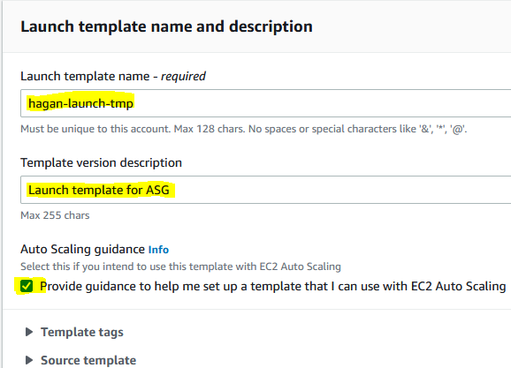
5. Under **Launch template contents**, fill out each required field and any optional fields to use as your instance launch specification.
   1. **Application and OS Images (Amazon machine image)**: Click the **Quick Start** tab and click **Amazon Linux**. and select the first Amazon Linux 2 AMI.  
      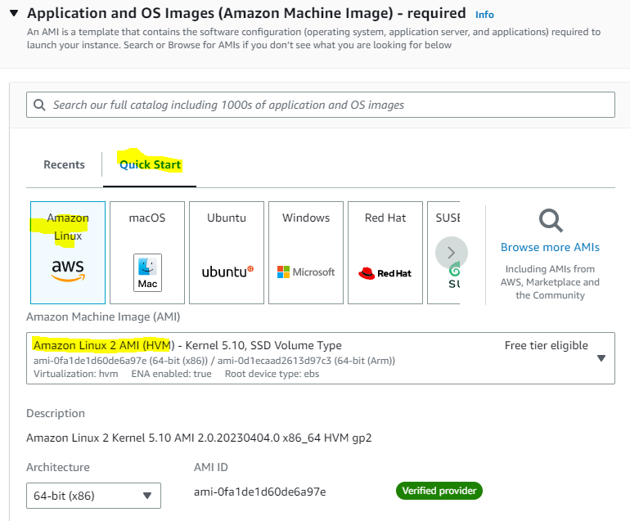
   2. For **Instance type**, select **t2.micro** (Free tier eligible).  
      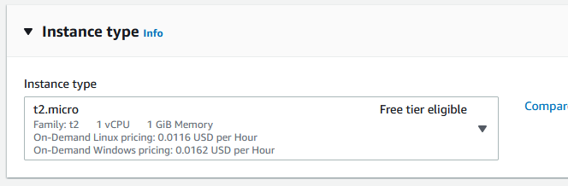
   3. **Key pair (login)**: Use the key pair from your webserver from the previous lab. You should be able to select from the dropdown.  
      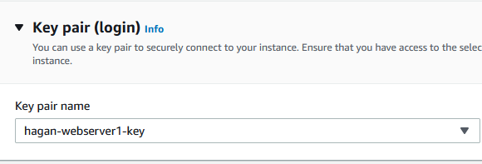
6. Under **Network settings**, do the following:
   1. **Subnet**: Choose *Don’t include in launch template*.
   2. **Security groups**: Choose the security group from your webserver in the previous lab.

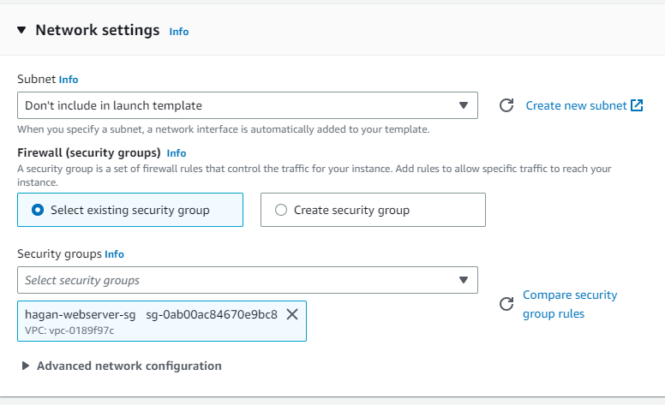

1. For **Storage (Volumes)**, leave the default value.
2. For **Resource tags**, click **Add tag** specify tags by providing key ***Name*** and value ***yourlastname-launch-tmp*** combinations.   
   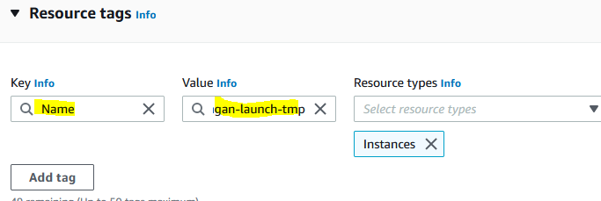
3. Expand **Advanced details.** Scroll to the bottom to User data. Paste the following into the *User data* box. **Be sure to enter a carriage return after last line**.  
   #!/bin/bash  
   yum update -y  
   yum install -y httpd.x86_64  
   systemctl start httpd.service  
   systemctl enable httpd.service

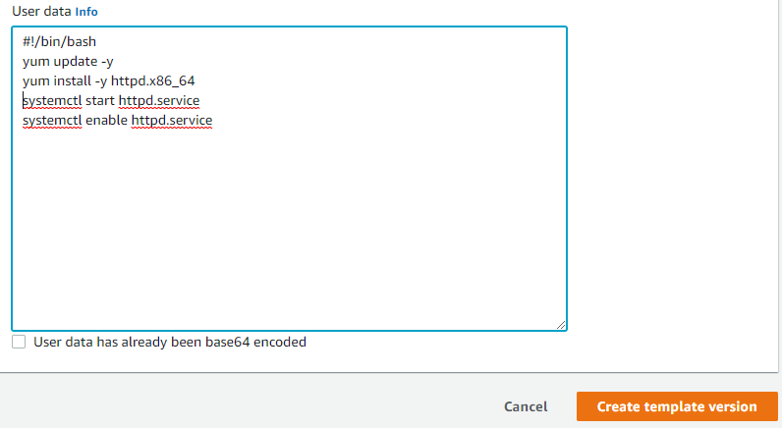

1. Click the **Create Launch Template** button after *Summary*.
2. Click the **View Launch Template** button.  
   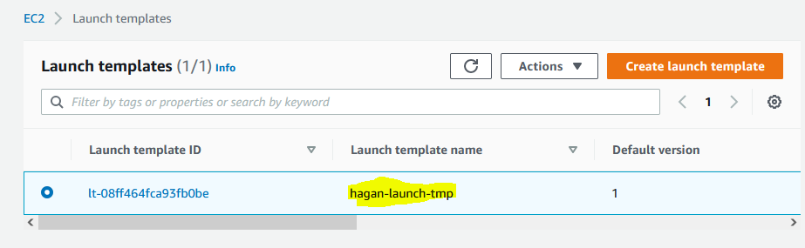
3. You should be able to see your newly created template

**Step 2 - Create an Auto Scaling group using a launch template**

1. Under EC2 and Auto Scaling click **Auto Scaling Groups**.
2. Click **Create an Auto Scaling group** button.
3. On the **Choose launch template or configuration** page, do the following:
   1. For **Auto Scaling group name**, enter the name ***yourlastname-asg***.
   2. For **Launch template**, choose the launch template you previously created.
   3. For **Launch template version**, leave default.  
      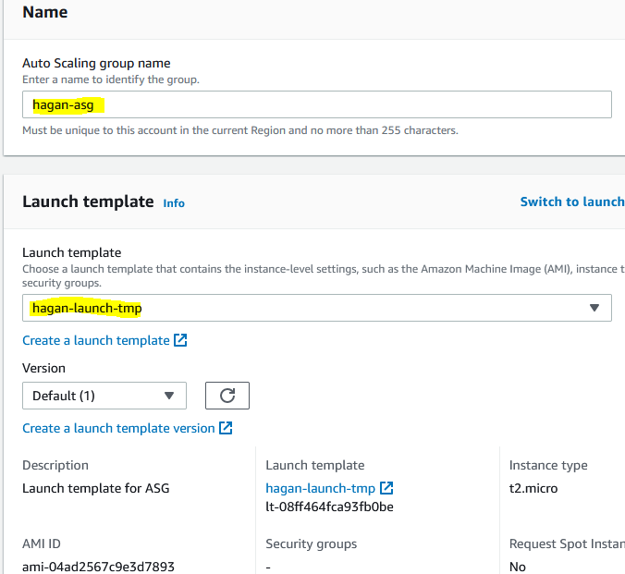
   4. Verify that your launch template supports all of the options that you are planning to use, and then choose **Next**.
4. On the **Choose instance launch options** page, under **Network**, leave the default VPC.
5. For **Availability Zones and subnets**, choose any 3 subnets by checking the box next to it. Click elsewhere to lock in you selections  
   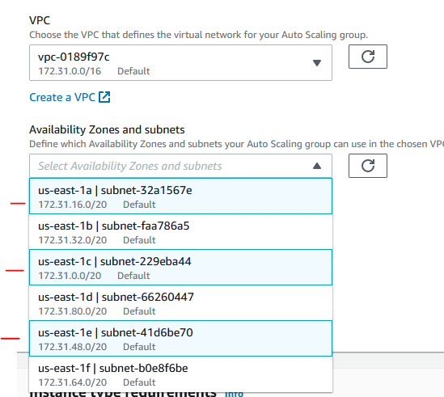
6. Choose **Next** to continue to the next step.
7. On the **Configure advanced options** page, leave the defaults and then choose **Next**.
8. On the **Configure group size and scaling policies** page, configure the following options, and then choose **Next**:
   1. For **Desired capacity**, enter **2**, for **Minimum** capacity enter **2** and for **Maximum** capacity enter **4**.
   2. Under Scaling policies choose **Target tracking scaling policy.** Notice in the *Metric type* dropdown some of the options that trigger the scaling. Leave the default values.
   3. Click **Next**
9. For **Add notification**, we can use this to send emails when a new instance is triggered by one the auto scaling metrics selected. Leave the default then choose **Next**.
10. Under **Tags** choose **Add tag**, provide a tag key ***Name*** and value ***yourlastname-asg*** and then choose **Next**.  
    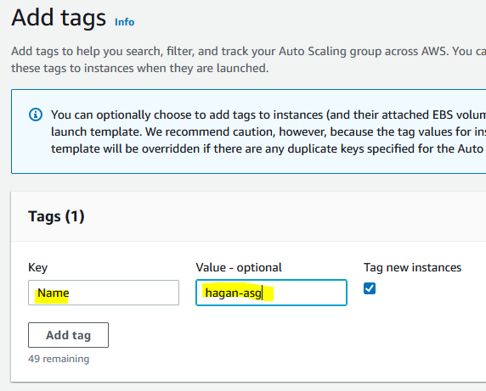
11. On the **Review** page, choose **Create Auto Scaling group**.

**Step 3 – Verify and testing Auto Scaling group**

1. On the Auto Scaling group page, check the box next to your newly created group.

2. Select the **Activity** tab and scroll down to *Activity History* to see instances being created.

3. You can also select the *Instance management* tab to see 2 instances launched and their Health status

4. Click **Instances** under ***Instances*** from the left pane to see you have 2 instances now running. Screenshot this and paste it in a Word document under heading Screenshot1.  
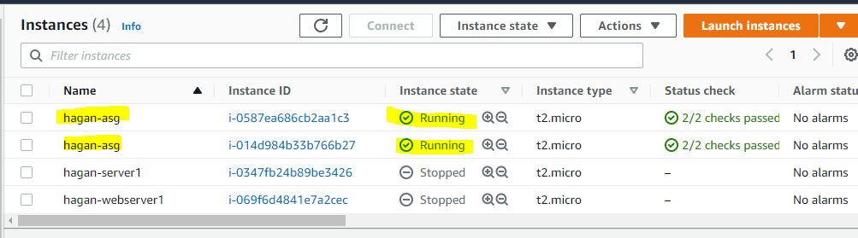

5. You should be able to see if your webserver is running now. To do so, check the box next to either running instance and go to the **Details** tab. Copy the Public DNS to clipboard (or just click the **open address** link) and paste into a private window. Did you get a webpage? Screenshot this and paste it in a Word document under heading Screenshot2.

6. To test the auto scaling feature, select one of the two instances checkbox, select **Instance state** dropdown, then **Terminate instance**.

7. Under **Auto Scaling** on the left pane, select **Auto Scaling Groups** and then check the checkbox.

8. Select the *Activity* tab and view the activities of an instance being terminated and a new one created. You may need to hit the refresh button a few times. Screenshot this and paste it in a Word document under heading Screenshot3.  
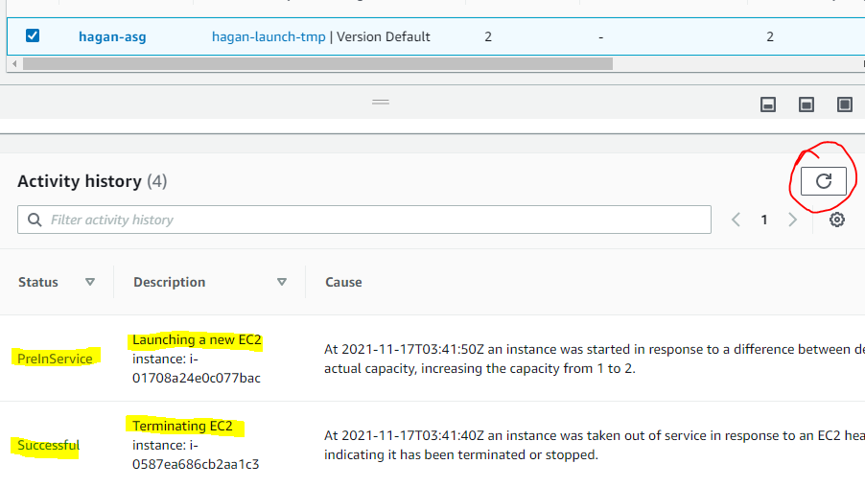

9. Click **Instances** under ***Instances*** from the left pane to see you have 2 instances now running and 1 terminated. Screenshot this and paste it in a Word document under heading Screenshot4.  
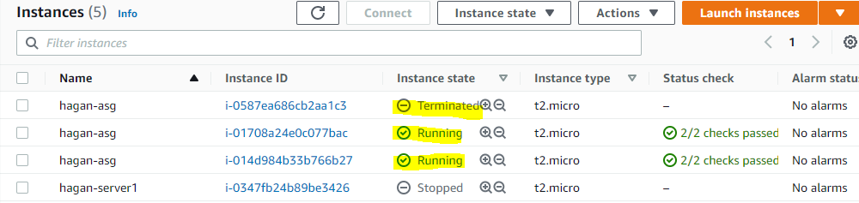

**Step 4 - Clean up**

1. Under **Auto Scaling** on the left pane, select **Auto Scaling Groups** and then check the checkbox.

2. Select **Delete** button, type the word ***delete*** to confirm deletion, then click Delete.

3. Click **Instances** under ***Instances*** from the left pane, and verify all instance have been terminated.

4. Upload Word Doc to Blackboard.